065a_CCSS_C08_EN_116218.tif

**.**

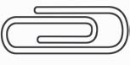

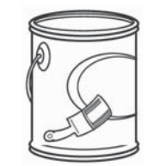

Name Date

**Check My Progress**

*(Lessons 1 through 4)*

**Estimate. Then measure to the nearest inch, $\frac{1}{2}$ inch, and $\frac{1}{4}$ inch.**

**1.**

**1.**

**2.**

**2.**

**Find each unknown number.**

**3.**

3 yd = in.

**4.**

2 mi = ft

**3.**

**5.**

in. = 8 ft

**4.**

**Choose the most reasonable estimate for each capacity.**

**5.**

**6** 1 gallon

10 gallons

100 gallons

**7.**

3 fluid ounces

3 cups

3 gallons

**6.**

**7.**

**WATER**

**Find each unknown number.**

**8.**

**8.**

2 c = fl oz

**9.**

**9.**

qt = 3 gal

**10.**

9 qt = pt

**10.**

**Solve.**

**11.** Sela needs 4 pints of milk for a recipe. How many cups of milk does she need?

**11.**

**12.**

**12.** An 8 in. × 8 in. pan holds 4 pints. A 9 in. × 13 in. pan holds

3 quarts. Which pan holds more? Explain.

**268**

**Grade 4 • Chapter 11** Customary Measurement